 | Year 12 Methods  TEST 2  Monday 8 April 2019  TIME: 45 minutes working  One page of notes allowed  Calculator Assumed  43 marks 5 Questions

Name: _______________________________ Teacher: ___________________________
Note: All part questions worth more than 2 marks require working to obtain full marks.

Question 1 (7 marks)
- Differentiate $\frac{x}{e^{x}}$ and simplify your answer if necessary. (3 marks)

- Using your result from (a) above and without the use of a Classpad, show how to determine the definite integral $\int_{0}^{1}{\frac{1-x}{{2e}^{x}} dx}$. (4 marks)

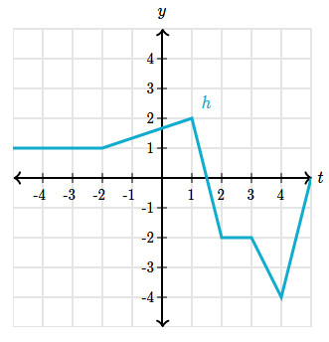
Question 2 (8 marks)
The graph of $h(x)$ is shown on the right.
- Evaluate the following definite integrals
- $\int_{-2}^{2 }{ h\left(x\right) dx}$ (2 marks)

- $\int_{-2}^{2}{h^{'}\left(x\right) dx}$ (2 marks)

- Determine the area bounded by the graph of $h^{'}(x)$ and the $x$ axis between $x=-2$and
$x=2$. Justify your answer. (4 marks)

Question 3 (10 marks)
Let $F(x)= \int_{0}^{x}{f\left(t\right) dt,}$ where $f(t)$ in the picture on the right.
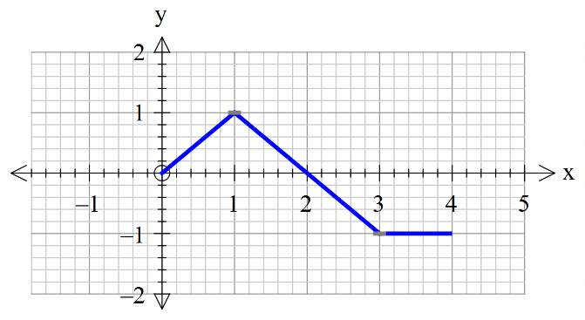
- Determine the value of $x$ for a maximum of $F\left(x\right).$ Briefly explain your reasons. (3 marks)

- Evaluate $F\left(3\right)$. (2 marks)

- Determine the value of $x$ for a maximum of $F'\left(x\right).$ Briefly explain your reasons. (3 marks)

- Evaluate $F^{'}\left(4\right)$. (2 marks)

Question 4 (10 marks)
A new substance labelled XX is found to decay by the rule , where equals the mass of the substance in kilograms at time minutes.
Determine the following:
- the initial mass of XX. (1 mark)

- the time taken for half of the mass to decay away to the nearest minute. (3 marks)

The radiation is safe for humans when the rate of decay is less than 100 kg per minute.
- Determine after how long the radiation will become safe for humans. (3 marks)

A different substance YY has a rate of decay given by , where equals the mass of the substance in kilograms at time minutes.
- Determine the total change in the mass from to minutes. (3 marks)

Question 5 (8 marks)
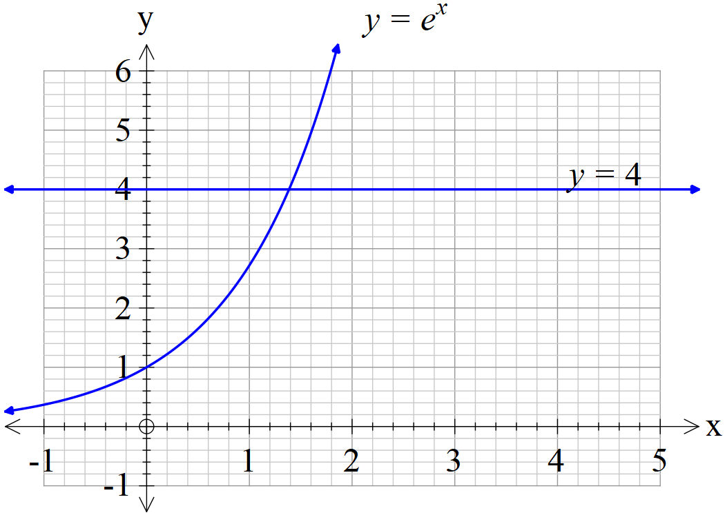
- Using the solve facility on your Classpad, determine to two decimal places the $x$ value where the two graphs above intersect. (2 marks)

- Determine to two decimal places the area bounded by and the $y$- axis.
(3 marks)

- Let where , determine the value of , to two decimal places, such that the area between and the $y$-axis equals 1.5 sq units. (3 marks)

Supplementary Page
Question Number: _____________

Supplementary Page
Question Number: _____________

